### First we will launch ec2 machine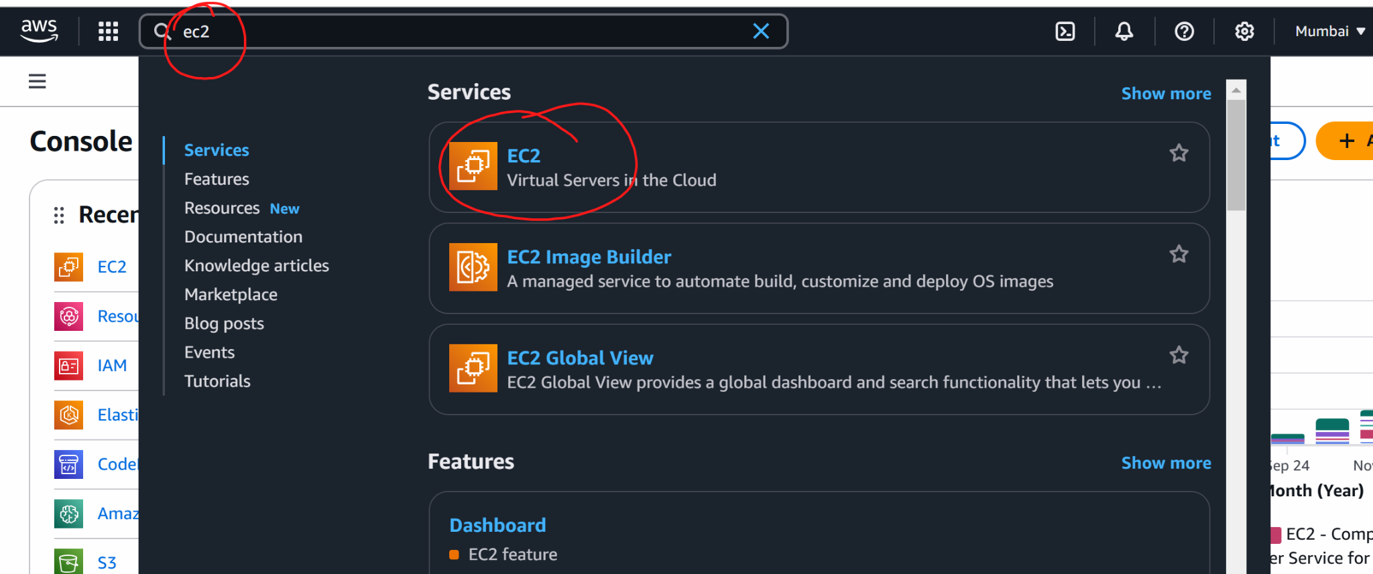

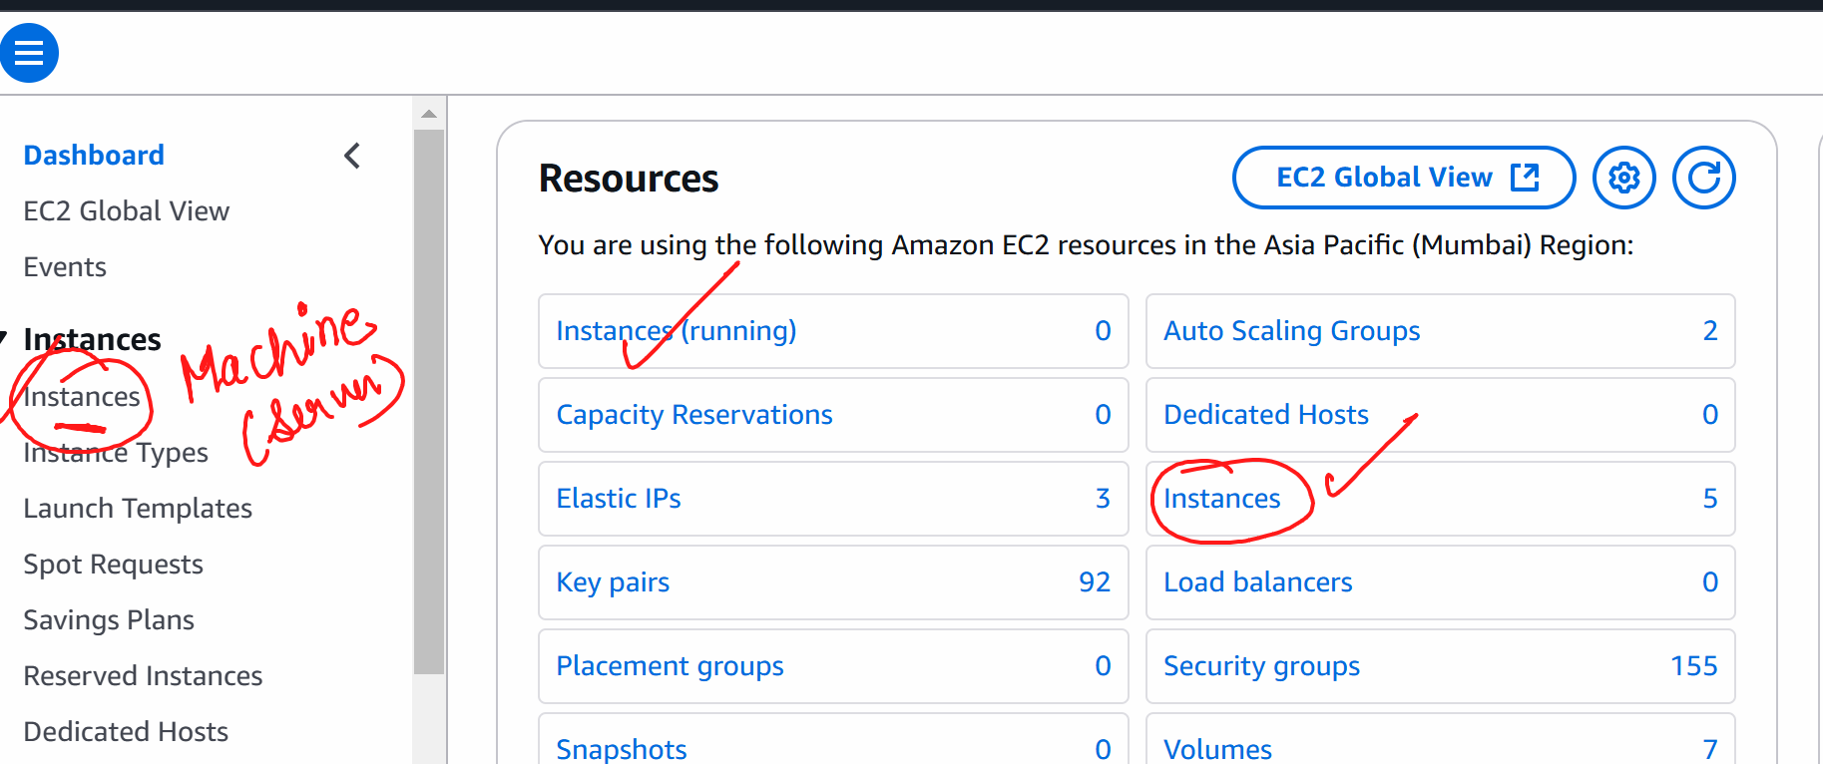

Launch instances

Give some name to the machine

Select ubuntu as ami

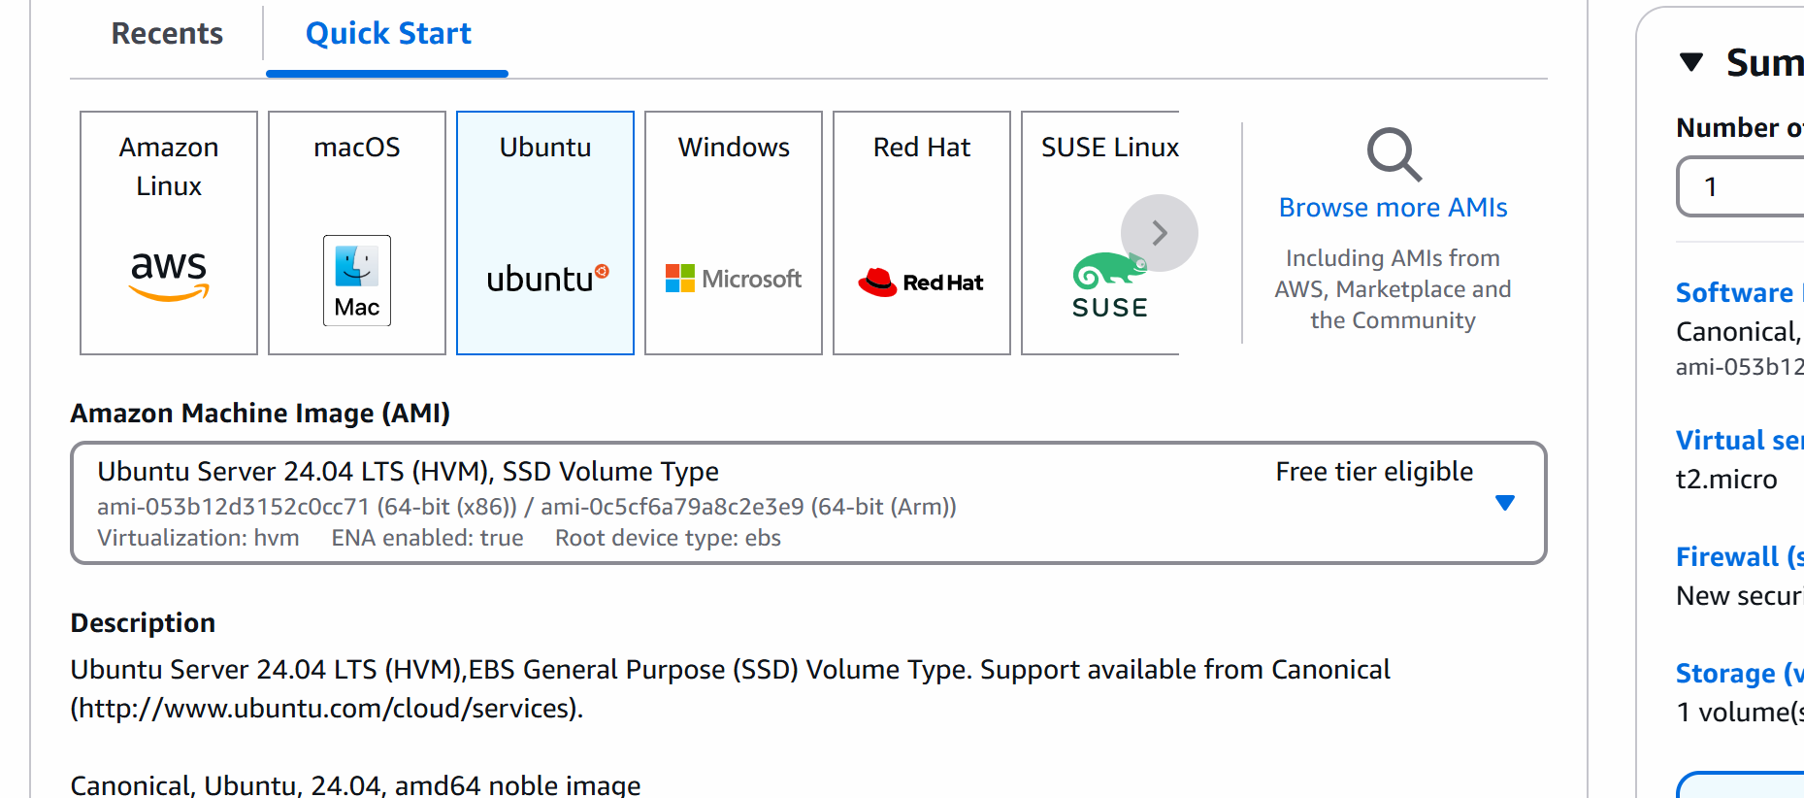

In instance type : t3.micro

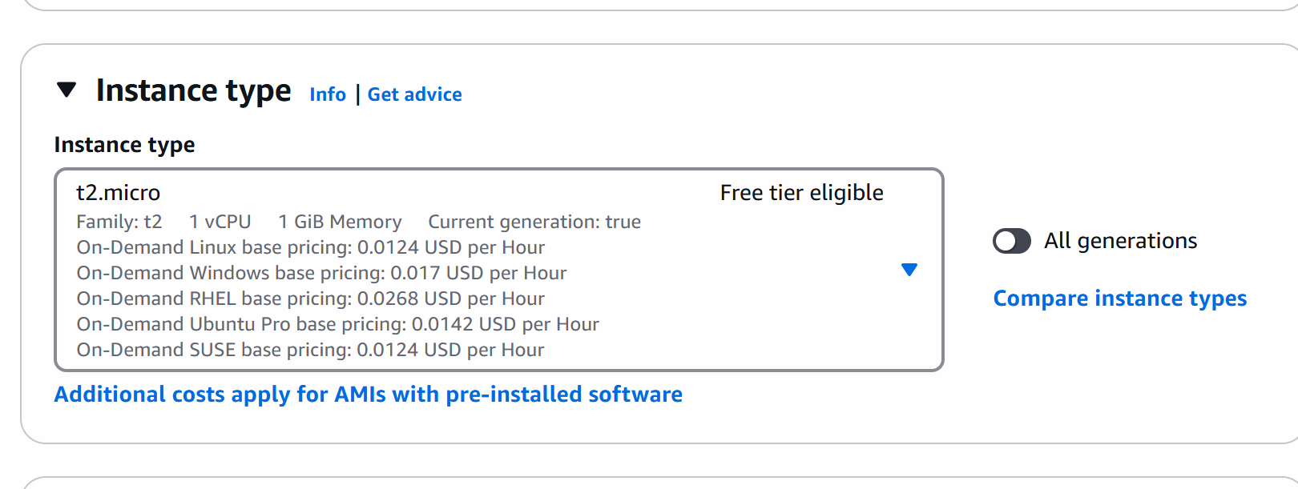

Create a new keypair

Give some name to the key -> create

Now u will see that key pair is downloaded to the laptop

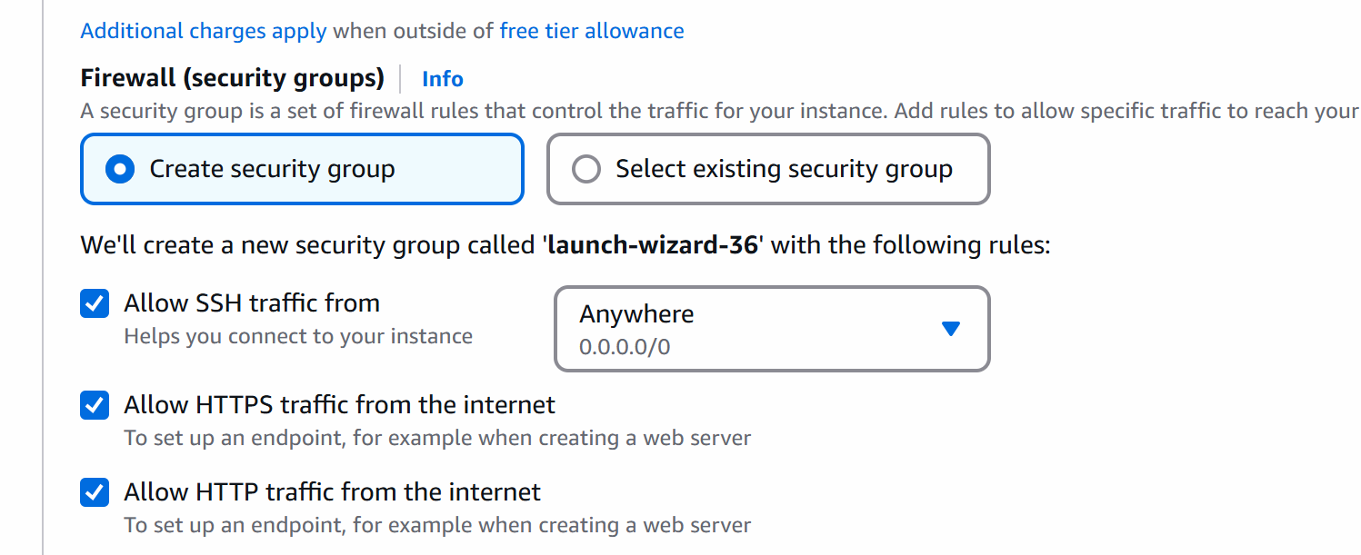

Launch instance

Select the machine -> connect to the machine

v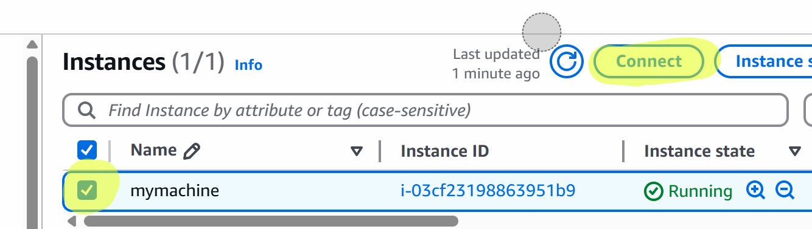

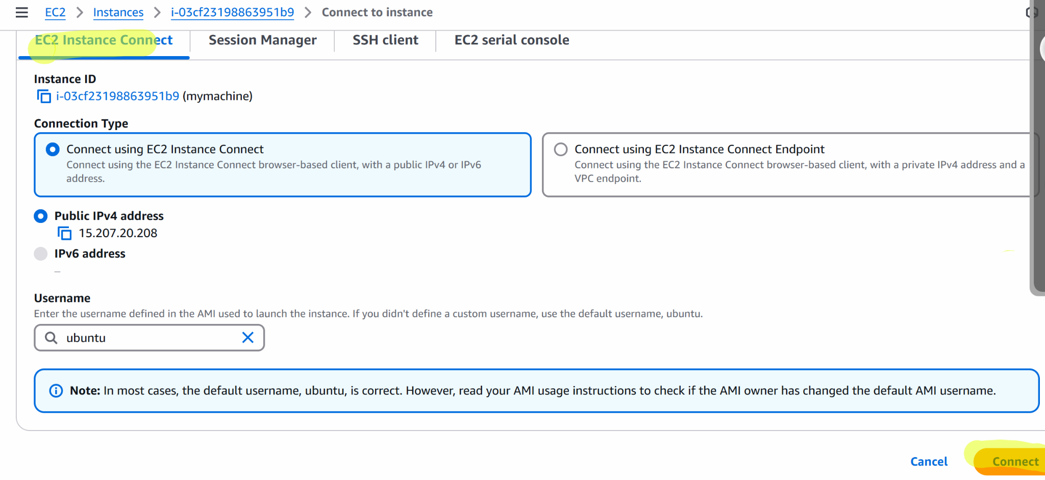

/

apt update

apt install apache2 -y

cd /var/www/html

51.21.198.115

rm index.html 51.21.198.115

51.21.198.115

Copy the public ip

And paste it in browser

Ensure that you are opening as <http://ip> address